VPN CONNECTIVITY ISSUE

If you're experiencing VPN connectivity issues with FortiClient VPN, there are Few common troubleshooting steps you can take to diagnose and resolve the problem.
1. Verify Internet Connection of User
- Ensure internet connection is stable and working properly. E.g. Ping Google DNS (8.8.8.8) without the VPN to confirm that internet connection is active.
- Type WIN+R ---type CMD---write the command on it
- Ping 8.8.8.8
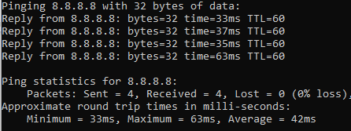
- If ok, then ping remote IP
- Type WIN+R ---type CMD---write the command on it
- Ping the IP: e.g. ping 152.52.60.62
- It must ping properly without any packet loss, otherwise VPN will not connect.
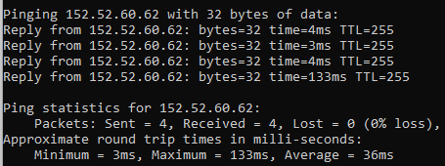
NOTE:
If not pinging its may be blocked from Firewall or Router end.

2. Check FortiClient VPN Version
- FortiClient versions might cause compatibility issues with the VPN server. E.g. if your company is using basic p2s VPN, installing a ZTNA version may not work. Please install the correct FortiClient VPN software.

- 3. Check VPN Remote Address and Settings
- Ensure that the VPN Remote address entered in FortiClient is correct.
- Remote address ---e.g.: 152.52.60.62
- Custom Port number ---e.g.: 10443
  - NOTE: Report address and custom port number must be above mentioned, unless VPN will not Connect.

4. Restart FortiClient & System

- Shutdown FortiClient from taskbar and open again to ensure it’s not a temporary issue.
- Reboot your computer to clear any temporary issues that might be affecting the VPN connection.
5. Contact Your IT Team
- If none of the above step’s work and you're still facing connectivity issues, you may need to contact IT administrator for more advanced troubleshooting.

